Sensor: The Eyes of IoT

***Sensors*** *are devices that measure, quantify, or respond to changes in their environment. They convert external stimuli or physical phenomena into electrical signals.*

### Characteristics

* **Sensitivity:** The ability of a sensor to detect and respond to changes in the measured parameter.
* **Resolution:** The smallest change in the measured quantity that a sensor can detect.
* **Accuracy:** The degree to which a sensor's measurements align with the true values.
* **Response Time:** The speed at which a sensor can detect and respond to changes in the measured parameter

**Deviations in Sensors**

* **Offset Error:** A constant difference between the sensor's output and the actual value.
* **Non-Linearity:** Deviation from a linear relationship between input and output.
* **Drift:** Gradual change in sensor output over time.
* **Noise:** Random fluctuations in the sensor's output.
* **Quantization Error:** Error due to the conversion of analogue signals to digital values.
* **Environmental Influences:** Sensitivity of the sensor to factors other than the measured property.

**Types**

* **Scalar Sensing:** Measures quantities that can be quantified by measuring changes in amplitude over time (e.g., temperature, pressure).
* **Multimedia Sensing:** Measures quantities with both spatial and temporal variations (e.g., images, sound).
* **Hybrid Sensing:** Combines scalar and multimedia sensing (e.g., using both temperature sensors and cameras for fire detection).
* **Virtual Sensing:** Uses data from existing sensors to infer information about unmeasured parameters (e.g., using soil moisture sensors to estimate water levels in nearby areas).

### Transducer: ~~Secretly a Sensor?~~

* A transducer also observes the changes happening in the physical world, **but unlike a sensor**, it **doesn’t require power**, it **measures the change** and converts it into the **form of voltage output**.
* There are two kinds of transducers, input transducers take energy or measurement in a form and convert it into electricity, for e.g. a microphone.
* 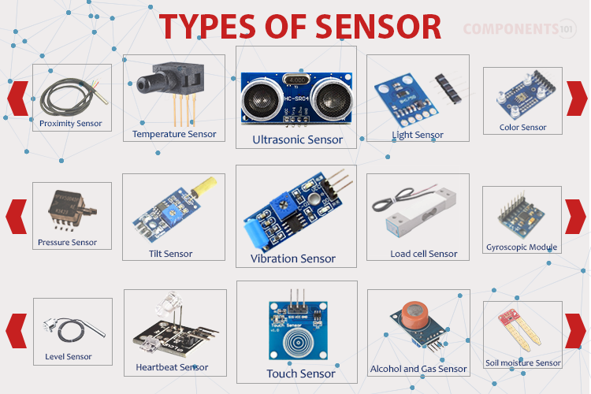Whereas an output transducer takes electrical energy and converts it into another form of energy, for e.g. a speaker.

Figure Various Types of Sensors in Daily Life

**Classification**

**Active and Passive Sensors:**

* Passive sensor requires an external source of power to work. For e.g. a thermistor, Light resistor, strain gauge, etc;
* While an active sensor doesn’t require any external source of power. For e.g. a Piezo electric, thermocouple, etc.

Excitation

Voltage

or,

Current Output

*External Source*

Wind Speed, Sun Radiation, Light Intensity

**S E N S O R**



Figure Excitation of a Sensor

Ground

**Analogue & Digital Sensors**

* The analogue sensor gives output in the form of analogue output when it detects changes in external parameters (wind speed, solar radiation, light intensity, etc.).
* 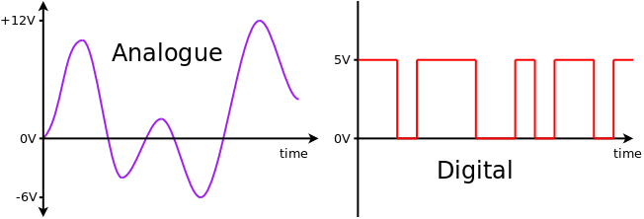An analogue sensor with an output range of 0 to 5V can give the output anywhere between 0V and 5V.

Figure Analogue Wave in Sensors

* Digital sensors produce discrete values (0 and 1’s).
* Discrete values are often called digital (binary) signals in digital communication.
* *Logic High* is treated as “1”, whereas *Logic Low* is indicated by “0”.

Figure Digital Wave in Sensors

**Scalar vs. Vector:**

* Scalar sensors measure magnitude only, while vector sensors measure both magnitude and direction.

**Power Requirements:**

* Sensors can be classified based on their power consumption, ranging from low-power to high-power devices.

**Measured Property:**

* Sensors can be categorized based on the specific parameter they measure, such as temperature, light, pressure, acceleration, or chemical composition.

### Work Culture Of Sensor:

Power Supply



Analogue Values from the Outside World

**S E N S O R**

Voltage

Or,

Current Output

C

Ground

Figure Working of a Sensor

### Sensor Applications in IoT:

* **Smart Homes:** Temperature sensors for HVAC control, motion sensors for security, and air quality sensors for indoor environmental monitoring.
* **Industrial IoT:** Temperature sensors for process control, pressure sensors for machinery monitoring, and vibration sensors for predictive maintenance.
* **Wearables:** Heart rate sensors, step counters, and oxygen saturation sensors for health monitoring.
* **Agriculture:** Soil moisture sensors, temperature sensors, and light sensors for precision agriculture.
* **Environmental Monitoring:** Air quality sensors, water quality sensors, and noise sensors for environmental protection.

**Challenges and Future Directions**

Despite significant advancements, several challenges remain in sensor development and integration:

* **Power Consumption:** Reducing the power consumption of sensors is crucial for extending battery life in IoT devices.
* **Accuracy and Precision:** Improving the accuracy and precision of sensors is essential for reliable data collection in critical applications.
* **Environmental Robustness:** Enhancing the ability of sensors to operate in harsh environments, such as extreme temperatures or high humidity.
* **Integration with IoT Platforms:** Developing seamless integration between sensors and IoT platforms to facilitate data collection, analysis, and visualization.

### Future research directions include:

* **Miniaturization of Sensors:** Developing smaller and more compact sensors for wearable and implantable applications.
* **Wireless Sensor Networks:** Expanding the capabilities of wireless sensor networks for large-scale monitoring and data collection.
* **Sensor Fusion:** Combining data from multiple sensors to improve accuracy and reliability.
* **Self-Calibration and Self-Healing Sensors:** Developing sensors that can automatically calibrate and recover from faults.

## Glossary of Unusual Terms

* **Quantify:** To measure or calculate the amount or value of something.
* **Temporal:** Relating to time.
* **Spatial:** Relating to space.
* **Stimuli:** Things that cause a reaction or response.
* **Phenomena:** Things that happen or exist, especially things that are unusual or interesting.
* **Analogue:** Relating to or using electrical signals that vary continuously in amplitude.
* **Discrete:** Separate or distinct.
* **Scalar:** Relating to or involving a quantity that has magnitude but not direction.
* **Vector:** Relating to or involving a quantity that has both magnitude and direction.
* **HVAC:** Heating, ventilation, and air conditioning.
* **Precision:** The quality of being exact or accurate.
* **Noise:** Random fluctuations in the sensor's output.

### Actuators: The Limbs of IoT

***Actuators*** *are devices that convert electrical, pneumatic, hydraulic, or other forms of energy into mechanical motion. They are used to control the movement or operation of machinery or systems.*

**Types**

* **Hydraulic Actuators:** Utilizes fluid pressure to generate linear or rotary motion.
* **Pneumatic Actuators:** Uses compressed air or gas to produce motion.
* **Electric Actuators:** Converts electrical energy into mechanical motion using motors or solenoids.
* **Thermal or Magnetic Actuators:** Uses heat or magnetic fields to generate motion (e.g., shape memory alloys).
* **Mechanical Actuators:** Employs mechanical components like gears, pulleys, or levers to convert motion.
* **Soft Actuators:** Made from flexible materials, they can perform delicate and precise movements.
* **Shape Memory Polymers (SMPs):** Changes shape in response to external stimuli.

**Characteristics**

* **Force/Torque:** The maximum force or torque an actuator can generate.
* **Speed/Response Time:** An actuator can change its position or state quickly.
* **Range of Motion:** The maximum distance or angle an actuator can move.
* **Accuracy:** The precision with which an actuator can control its position or movement.
* **Durability:** The lifespan and resistance to wear and tear of an actuator.



* **Environmental Tolerance:** The ability of an actuator to operate in harsh conditions (e.g., extreme temperatures, humidity).
* **Energy Consumption:** The amount of power required for an actuator to operate.

### Actuator Action:

Energy

Input Signal

Motion /Force

**A C T U A T O R**

Figure Block Diagram of Actuator Working

**Challenges and Future Directions**

* **Energy Efficiency:** Developing more energy-efficient actuators is crucial for extending the battery life of IoT devices.
* **Miniaturization:** Creating smaller and more compact actuators for wearable and implantable devices.
* **Precision and Control:** Improving the precision and control capabilities of actuators for critical applications.
* **Integration with IoT Platforms:** Ensuring seamless integration between actuators and IoT platforms for efficient control and automation.

### Future research directions include:

* **Soft Robotics:** Developing advanced soft actuators for applications requiring gentle interaction with objects.
* **Biomimetic Actuators:** Creating actuators inspired by biological systems for enhanced performance and capabilities.
* **Self-Healing Actuators:** Developing actuators that can repair themselves after damage.

## Glossary of Unusual Terms

* **Pneumatic:** Relating to or operated by air or gas.
* **Hydraulic:** Relating to or operated by water or other liquids.
* **Solenoid:** A coil of wire with a movable iron core, used to produce a magnetic field.
* **Biomimetic:** Imitating or inspired by biological systems.